<<Program Name>>
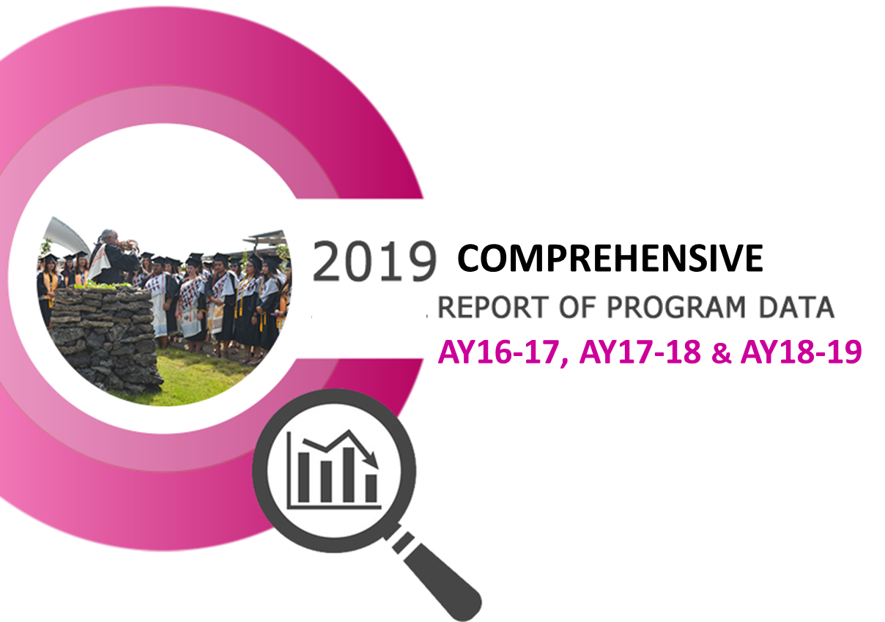

1. Program Description
Description of the program from the catalog.

2. Analysis of the Program
For the three-year review period, discuss the program’s strengths and weaknesses in terms of demand, efficiency and effectiveness based on an analysis of ARPD Quantitiative Indicators. CTE programs must include an analysis of Perkins Core indicators met and unmet.
Include Significant Program Actions (new certificates, stop outs, gain/loss of positions) and results of the program’s three previous consecutive annual action plans.

3. Program Learning Outcomes (PLOs)
- List of the Program Learning Outcomes (PLOs) with their alignment to the College’s Institutional Learning Outcomes (ILOs).
- List of all courses that have been assessed during the three-year review period and the PLOs to which those courses’ Course Learning Outcomes (CLOs) are aligned.
- Discussion of the program’s PLO assessment results based on course CLO assessments.
- Discussion of the program’s strengths and challenges in helping students meet their program learning outcomes, and changes that have been made as a result of assessments.

4. Action Plan
Provide a detailed action plan to improve student learning and success over the next three years. Discuss how the action items within the plan support the collegeʻs Mission with specific reference to the Strategic Directions plan: HawCC Strategic Directions Plan 2015-2021.pdf
In addition to the overall action plan for the program, include specific action plans for the program’s Performance Indicators and any Perkins Core Indicator for which the program did not meet the performance level in the final year of the three-year review period (AY18-19).

5. Resource Implications & Budget Asks
(physical, human, financial)
Provide a detailed discussion of the program’s current resources, resource gaps and requests for new or re-allocated resources. Provide detailed documentation for each resource request including projected costs and timeline for procurement to meet the program’s needs. Resource requests must align to and support the action plan above.
Attach additional documentation and evidence as necessary to clearly support each request.
CTE programs mush provide evidence of industry trends to support each request, including Advisory Council minutes or documentation of discussion(s) with industry experts.

